Instruction manual
for online NBT

Registration process

The registration process in the platform must be done according to the dates specified by CEA where you started the NBT application.

Go to https://cetap.edtest.ai using a desktop or laptop computer with webcam (integrated or external device), in one of these web browsers: Google Chrome or Mozilla Firefox (you will find detailed suggestions in the manual of application conditions and technical recommendations).

- To start, read the instructions below:

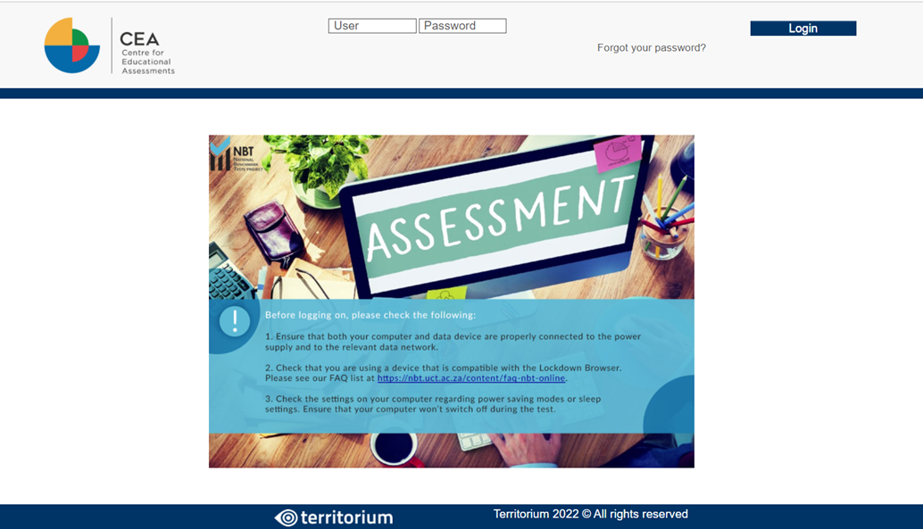

- Next step is to log in with the NBT Reference and password provided by CEA where you started the NBT application process.
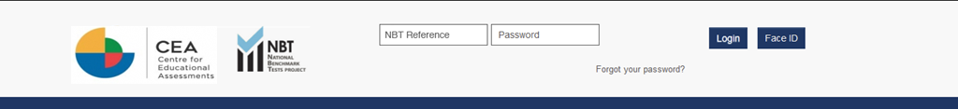

If you know your username but you forgot your password, follow the next steps:

  - Click on the text “Forgot your password?”.
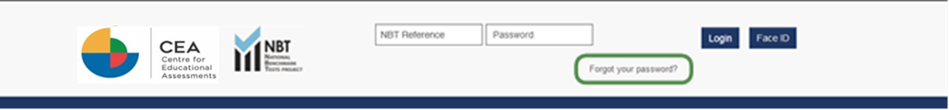

  - Introduce your username into the text field and click on Send. A message will be sent to your email registered.
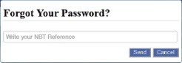

  - Check your email. Look for the message with subject “Recover your password”, open it and click on the link to change your password.
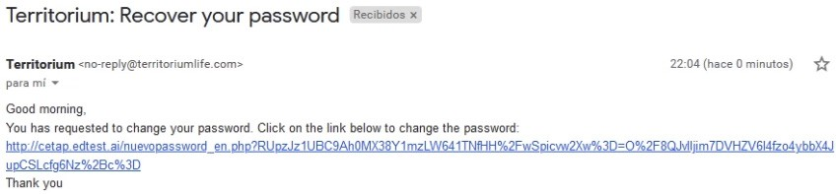

  - Introduce a new password in both text fields, and click on Send to generate your new password.

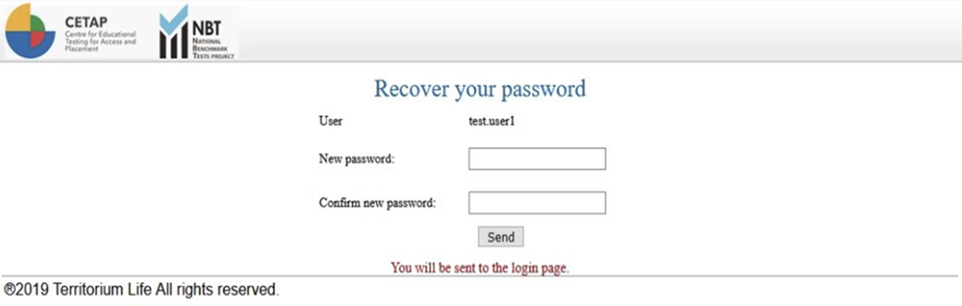

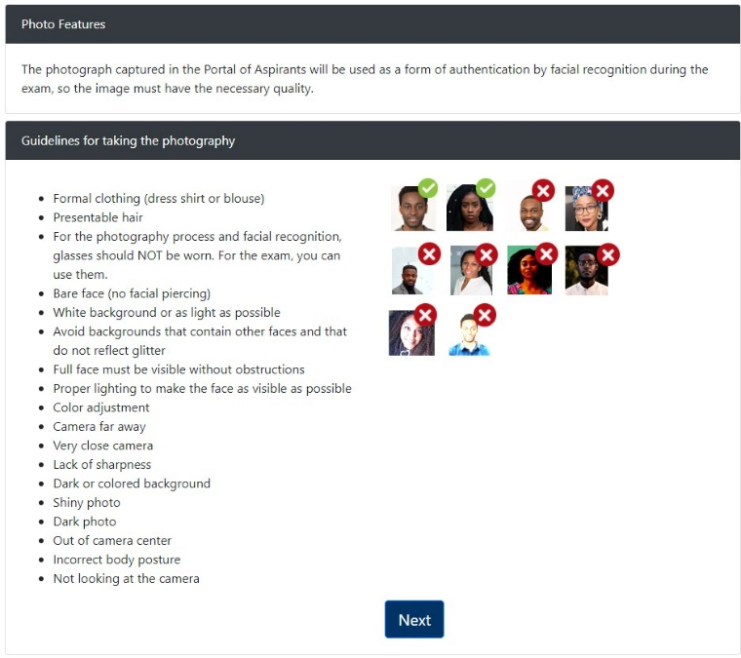
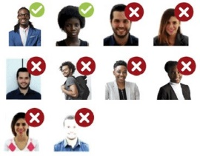
- You will need to register your photo for identity validation. You can see some instructions and recommendations displayed on the screen.

The first time you log in into the platform, the browser will ask you to allow the webcam use, click the button “Allow” to continue the registration process.
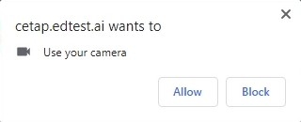

- Once the use of webcam is allowed, you will see your face in the photo capture frame. Follow the guidelines to complete this process successfully. It is also recommended taking the picture in the same place where you will be doing the test.

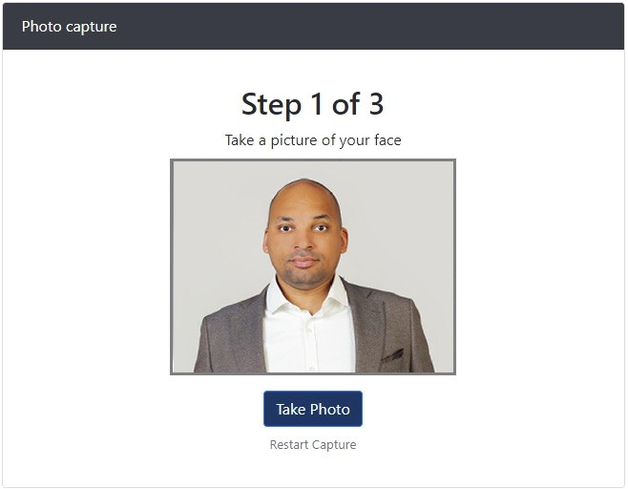

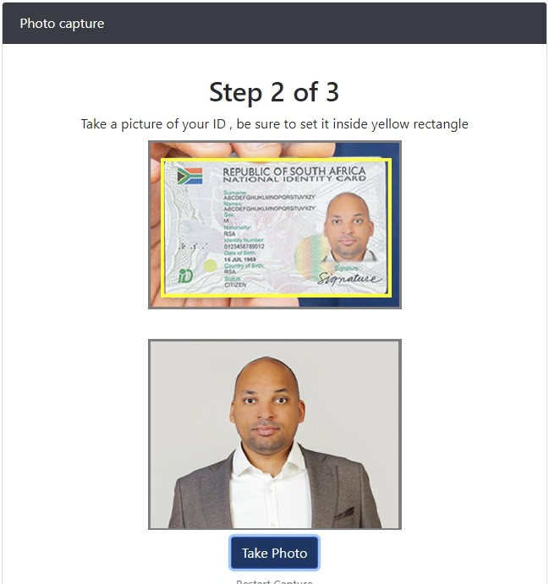
- You have to take two photos. Click on “Take Photo” to take the first one, then click on it again to take the second one.

Please note that the second photo must be of your ID. Be sure that your ID fits into the yellow frame.

If you consider the photos do not fit the guidelines, you can click the button “Restart capture” and start again.

- Once you take the two photos, click the button “Validate Photo”.
After the system validation, you can get two different messages: Success or Error.

If your validation was successful, you will be redirected automatically to login page, the registration process is finished.
If your validation was unsuccessful, you will have to go back to step 5.

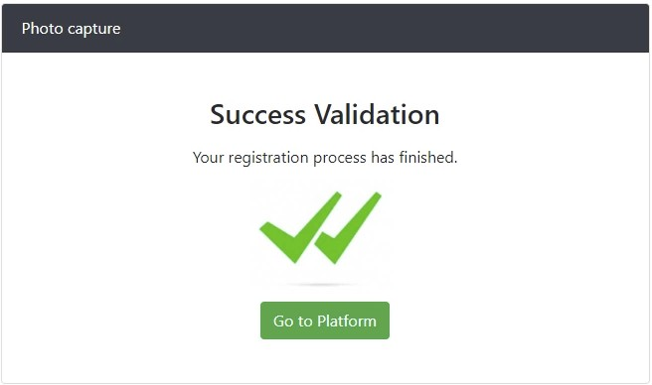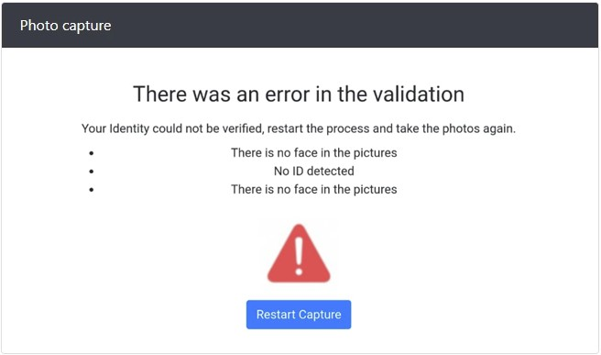

The two pictures you have captured will serve as reference to validate your identity before and during the test.

Test application process

Once your registration online is complete, go to https://cetap.edtest.ai on the date and time indicated by the CEA. Remember to use a desktop or laptop computer with integrated or external webcam, and use one of these browsers: Mozilla Firefox or Google Chrome. Make sure the power supply to the computer is in place, your data device is charged and/or connected to appropriate outlets and computer settings are changed to prevent it from going into sleep mode.

- You have two options to sign in into the platform:

  - Enter the username and password that was sent to you by the CEA where you started NBT application. Next click on the button “Login”.
Login

  - Using facial recognition. Click on the button “Face ID”, take a photo and click on “Verify Identity”. Remember to allow the webcam use if the browser prompts for it. If your validation is successful, you will be redirected automatically to home page, in case that the validation is unsuccessful, an error message will be shown.
Face ID

If you are not registered or registration process is incomplete, an error message will be shown. You need to go back to registration process and complete it successfully.

- Once you have logged in, you will see the instructions for installation of the LockDown Browser.
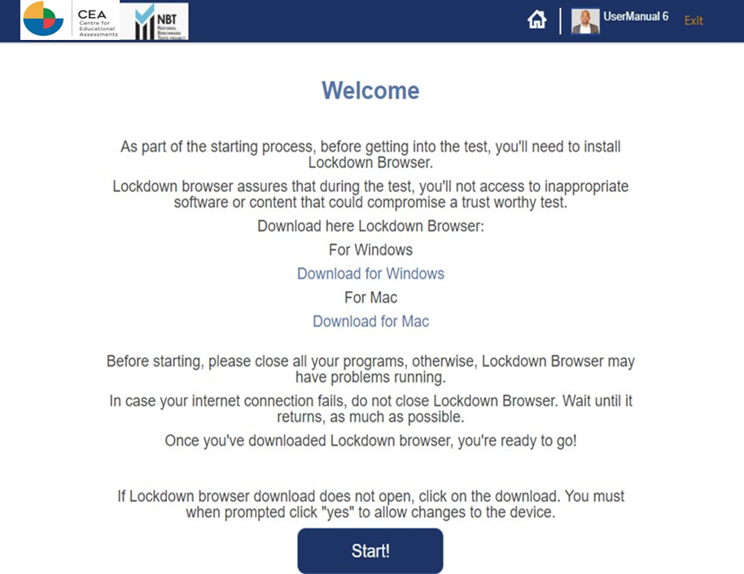

LockDown Browser is a client application that is installed to a local computer. Both the Windows edition and the Mac edition of the browser are based on Chromium, Google's open source framework. You do NOT need Google's Chrome browser installed; nor will this version affect a Chrome browser that's already installed.

You may watch this video about the LockDown Browser: https://web.respondus.com/lockdownbrows- er-student-video/
According to your operating system, choose a link to download LockDown Browser setup file.
Windows: https://archivos.territorio.la/lockdownbrowser/LockDownBrowserOEMSetup.exe
MAC: https://archivos.territorio.la/lockdownbrowser/InstallLDBOEMSDK.zip
System Requirements for LockDown Browser:
Operating Systems:
Windows: 10, 8, 7.
Mac: MacOS 10.12 or higher.
Memory:
Windows: 75 MB permanent space on the hard drive. Mac: 120 MB permanent space on the hard drive.

Save the file in your computer. Once downloaded, execute the installation file.
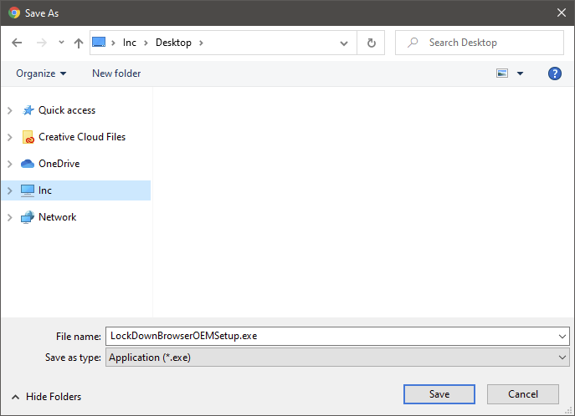
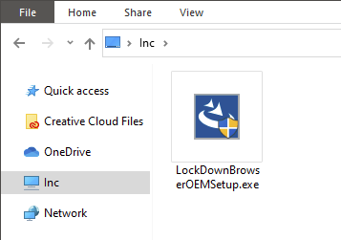

Select the setup language and click on the button Next.
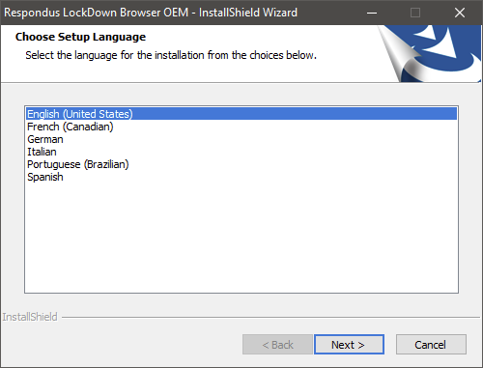

Wait until installation is complete, then click on the button Finish.
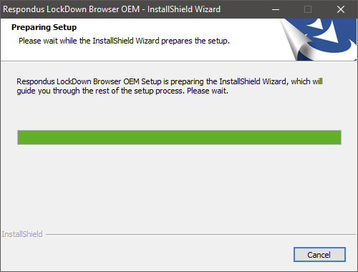
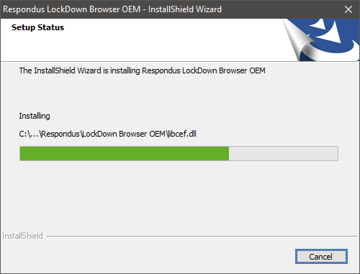
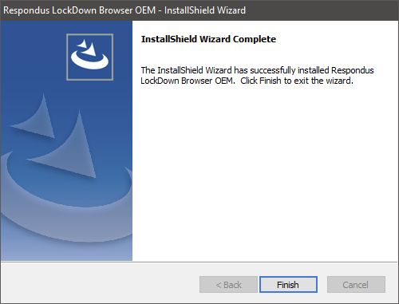

Once LockDown Browser is installed in your computer, you can go to the platform and click on the button “Start!”.

Your browser will prompt you asking to open LockDown Browser. Click on the button “Open LockDown Browser OEM. You can check the option ”Always allow platform to open links of this type in the associated app” (optional).

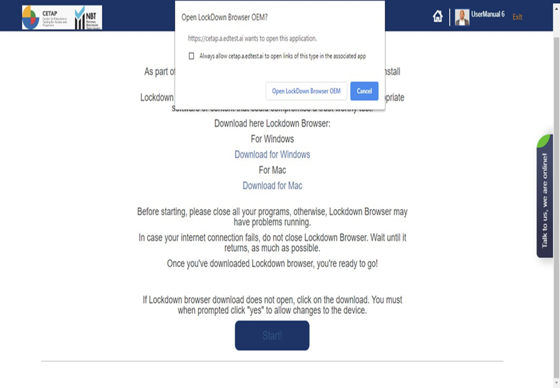

Wait until the application loads.
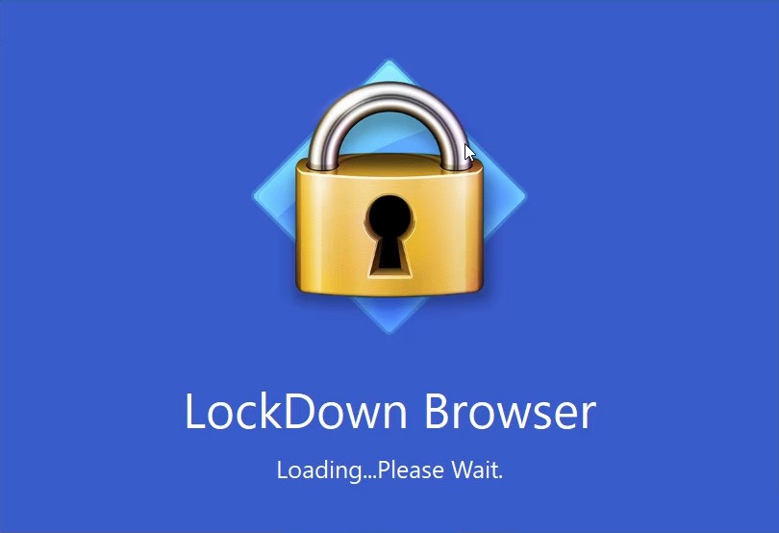

- Now you are ready to go. You will see on the screen the tests available for you:

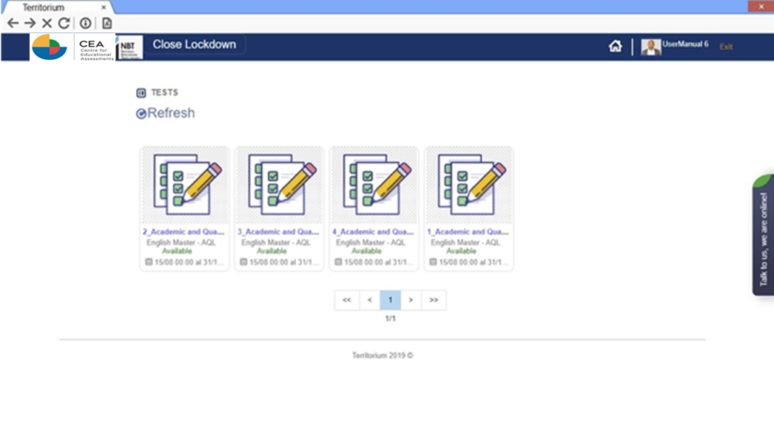

Each test has a status; it could be:

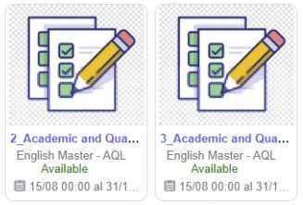
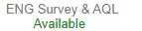
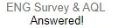
Available – The test is ready to be taken. Answered – The test has been completed. Finished – The date to take the test is over and the test is no longer available.

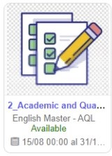
Click on the name of the test you want to start:

- Once the test starts, you will see at the top of the screen your webcam and a timer showing remaining time to complete the test.
You will also see the instructions to navigate and answer the test.
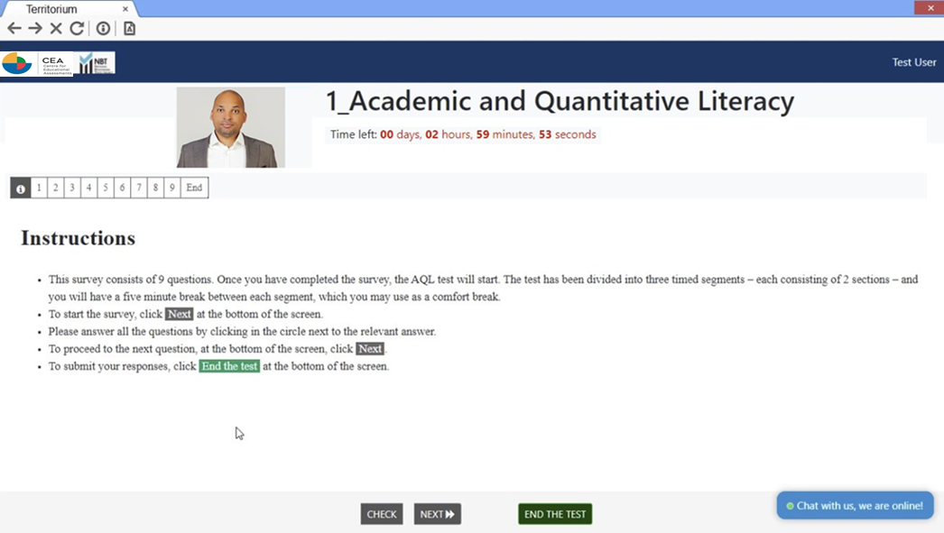

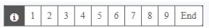
Below the webcam frame, you will see a list of numbers, each one corresponds to one question. You can click on the button . anytime if you want to read the instructions, also you can click on any number to browse through the questions.

At the bottom of the screen you will find the navigation buttons.

REVIEW

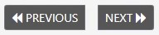
You can browse through the questions using the button Next (next question) or Previous (previous question).

You will see the questions one at a time, each with four answer options.
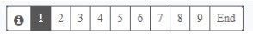

1) ID TYPE / TIPE ID

South African Foreign

Once you select an answer, the question number will be struck through. If you want to mark a question to be reviewed later, you can click on the button REVIEW and the question number will be highlighted.
REVIEW
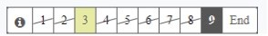

9) SCHOOL LANGUAGE / SKOOLTAAL Afrikaans
English Other

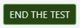
Once you answer all the questions, click on the button “End the test”. You will be prompted if you want to submit the test, click on “Accept” to finish the test or "Cancel" to go back and review your answers.
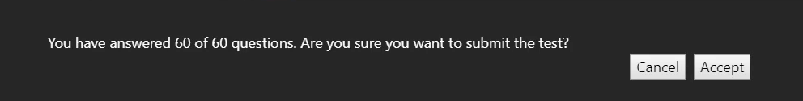

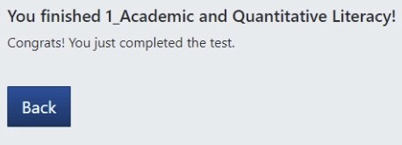
While your answers are being sent to the system, do not click on any buttons, press any key on keyboard or close the window. Wait until the process finish and the feedback screen shows up. It may take a few seconds.

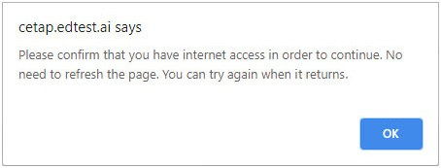
If your internet connection fails during the test, a message like this will show up.
General observations

Follow the instructions to continue with the test once your internet connection is restored.

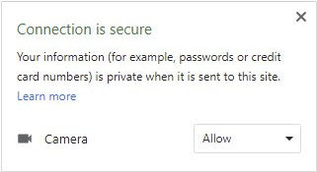
Remember to allow the use of your webcam every time your browser prompts to.
Keep it active during the test.

Your answers will be saved during the test. If you have any trouble (window closes, internet connection fails, energy supply fails, etc.), you can resume the test later from where you left off.

Those incidents will be registered in the platform and CEA can consider them to validate your test results.

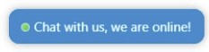
For any further communications, suggestions or any additional information that we can provide to help you, please contact us by clicking the Live Chat button on the right side of the screen.

