Writers are reminded that the test is undertaken in a secure proctored online environment. You will be monitored throughout the test to ensure that you follow all testing procedures. Your entire test session will be recorded. Please ensure that you comply with all test rules and requirements to avoid the invalidation of your test.

1. **GENERAL RULES**

* You should take your test in a quiet room with a blank wall behind you, with good lighting.
* The Laptop or Computer camera must be operational and facing your face at all times during the test, otherwise your session may be invalidated.
* There is a photo panel visible to you during your test so that you can check your camera is functional and your face visible. If your face is not recognisable for any reason including poor camera angle, lighting etc, and your test will be invalidated.
* Your face must be visible so no hoodies or clothing that obscures the face are allowed.
* You may not wear headphones/earphones/earbuds during the test session. Your test will be invalidated if you do so.
* Any other person entering the room, or movement in the room will be picked up by the camera and will invalidate your test session.
* You may only have a piece of paper and pen/pencil in the test room. Books, cell phones, smart watches, calculators and any other items are strictly prohibited. These items will be picked up by the system and will invalidate your test session.
* If you are using your cell phone as an internet hotspot, this must be placed away from your workstation and must not be accessible during the test session at any time. If you do so your test session will be invalidated. Please ensure the cell phone being used as a hotspot is connected to a charger to avoid any unauthorised access to the cell phone during the session.
* Bathroom breaks are permitted but must be less than 5 minutes in duration. Please ensure that you do not exit the test or the lockdown browser and ensure that your laptop or computer does not enter “sleep” or “screen/power saver” mode while you are away as this may affect your session.
* You may have a bottle of water (or other liquid refreshment) with you during the test.

1. ***REQUIREMENTS TO WRITE NBT ONLINE?***

In order to write online you will require the following;

* Access to a quiet room with a blank wall behind you and good lighting.
* You will need an internet linked **laptop or computer** equipped with webcam, microphone and a stable internet connection (Please ensure that you have access to the same computer for both the simulation and test).
* You will need to have with you your **valid ID or passport** that was used when you registered to write the NBT (*If you do not have a South African ID booklet or foreign passport and you need to use your birth certificate for ID verification, you will need an affidavit from the police including a recent ID photograph that confirms your identity*). This must be stamped with the relevant police stamp or will not be accepted.
* Your laptop or computer should have the minimum specification as outlined on the table below.

(***Kindly note that Cellphones, iPads and Tablets are NOT allowed and are NOT supported):***

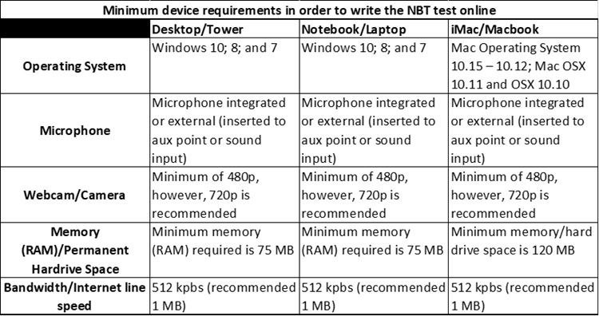

* You must have administrator rights on the computer as you are required to download the Lockdown Browser software onto the computer and may be prompted for the admin password. The test platform has a built-in communication or “chat” function. This chat function will allow you to send real-time queries to a consultant who will assist. Please note that no headsets may be worn during the test session.
* **Note:** The test environment does not require a high-speed internet connection and the minimum recommended line speed is **1MB** (an entry level wired/fibre or 3G connection should be adequate). **Data usage is relatively low, and you will require approximately 1G to complete each test.**

1. **COMPUTER SETTINGS AND RECOMMENDED BROWSERS**

* It is the responsibility of the writer to ensure that they have administrator rights on the computer as you are required to download a piece of software called the **“Lockdown Browser”** and you may be prompted for the admin password to install this.
* The Lockdown Browser is downloaded only once you are logged into the test platform ([**https://cetap.edtest.ai/**](https://cetap.edtest.ai/)**)** and instructions are provided on-screen.
* **Google Chrome & Firefox browsers** are recommended to ensure you have the best experience.
* The writer is also responsible for ensuring that the webcam is operational and that **webcam** access to apps including the "Lockdown Browser" are enabled.
* A **microphone** is recommended but not compulsory as the test platform does has a built-in communication or “chat” function to allow you to send real-time queries to a consultant for assistance.
* Please ensure that laptops, computers, routers, mobile hotspots etc. remain connected to mains power/chargers to avoid battery failure during the tests. Should your device shut down, you will be exited from the test.

1. ***THE SIMULATION TEST (COMPULSORY)***

You are required to complete the COMPULSORY simulation before the Wednesday preceding to the test day. You will be communicated the specific deadlines for this simulation prior to the test. The purpose of this short simulation is to allow writers to familiarise themselves with the online test environment and go through the login processes and software downloads to avoid unexpected problems on the test day. Writers will go through the login processes and software downloads, to avoid unexpected problems on the test day and ensure a better test day experience. To ensure a better test experience, the **Simulation** **is compulsory for all registered students, ensure the lockdown browser is downloaded.**

**There are two parts to the simulation:**

1. **The Photo ID Verification Process**
2. **Completion of Sample Test – 5 Questions (after Lockdown Browser Download)**

**Writers are required to complete both steps for the simulation to be successfully completed. If you do not complete these you will not be permitted to write the NBT on the test day. The Simulation will be available from 24th April for registered writers. Please allow seven days after registration for an online session, before accessing the platform. Please note the Simulation is not available on the test weekends.**

You must complete the simulation prior to the last Wednesday before the test day. . This simulation will incorporate the Photo and ID verification process, and Lockdown Browser download, to mirror the actual test day and ensure that any potential difficulties are identified prior to the test session. For this reason, the simulation **must be done on the computer that you will use on the test day**. The simulation should take about 15 minutes to complete.

## **4.1 SIMULATION PROCEDURE**

* The simulation is accessed from the link <https://cetap.edtest.ai/>
* The test on the test date will also be accessed from this link.
* In order to login you require:
  + **Your Username which is your NBT Ref No.**

and,

* + **Password is NBT123456 (*You will be prompted to change this*)**
* If for any reason you forget your password, please click “forgot password” to reset and follow the onscreen instruction.
* All writers will be required to go through a security confirmation and must have their photo ID / passport available.
* A clear recognisable image of yourself and ID must be captured during the ID verification process. Follow all onscreen instructions, review the images for clarity and retake if necessary.

## **4.2 ONLINE SUPPORT:**

* Online support will **only** be available between **08h00 and 16h00** on the business days of the simulation.
* Online support will be available for the full duration of the test on the test date. The online chat function should be used while logged into the test platform.
* Alternatively, the helpdesk may be contacted by email on [nbt@uct.ac.za](mailto:nbt@uct.ac.za) or call 021-650-3523.

1. ***THE TEST DAY***

On the test day, you are required to login no longer than no later than 08h30 to allow sufficient time to allow for the Lockdown Browser download and resolve any equipment issues you may have.

* A working camera is required which must remain on for the duration of the test session.
* **Note:** Note: The Online NBT Test sessions start at 09h00 in the morning (AQL) and afternoon sessions (MAT) start at 14h00.
* You will not be able to access the test prior to the start time. If you entered the test platform early, you may need to **refresh the test page (F5)** closer to the start time for the test to appear.
* Each test is approximately 3 hours long.

Any deviation from these start times will be communicated to you for specific test dates.

The writer is responsible for ensuring that all rules and requirements are adhered to. The NBT takes no responsibility for test sessions that are not completed and/or invalidated due the writers computer or peripheral equipment (camera's, microphones, routers, screens, RAM etc) failure or software issues or settings, or loss of connectivity, loadshedding or any other occurrence not linked to the test platform. Where this occurs the writer will need to re-register to write the NBT.

**Writers are reminded that the test is undertaken in a secure proctored online environment. You will be monitored throughout the test to ensure that you follow all testing procedures. Your entire test session will be recorded for the purpose of ensuring test security. Please ensure that you comply with all test rules and requirements to avoid the invalidation of your test.**